Practical - 4
Practical Title: JavaScript DOM Manipulation, Event Handling, and UI Interactivity

Problem Definition: Add dynamic UI components such as collapsible FAQ, modal popup,

image/content slider, notification banner, hamburger menu, and light/dark

theme switcher using JavaScript.

Theory
1.How are DOM elements selected and modified?
Answer: DOM elements are selected using methods such as getElementById(), getElementsByClassName(), getElementsByTagName(), querySelector(), and querySelectorAll(). After selecting an element, JavaScript can modify its content using properties such as innerHTML and textContent, change its attributes, or modify its CSS styles.

Example:
const element = document.getElementById("demo");
element.innerHTML = "Hello World!";
Here, getElementById() selects the element and innerHTML changes its content.

Reference Link:
https://www.w3schools.com/js/js_htmldom_elements.asp
https://www.w3schools.com/js/js_htmldom_methods.asp

Are event listeners attached correctly?
Answer: Yes, event listeners are correctly attached when addEventListener() is used with the event name and the function that should execute when the event occurs.
Example:
const button = document.getElementById("myBtn");

button.addEventListener("click", function() {
alert("Button clicked!");
});
According to W3Schools, addEventListener() attaches an event handler to an element. It also allows multiple event handlers to be attached without overwriting existing handlers. The event name should be written as "click", not "onclick"

Reference Link:
https://www.w3schools.com/js/js_htmldom_eventlistener.asp

3. Is localStorage used for remembering the theme choice?
Answer: localStorage can be used to remember the user's light/dark theme choice even after the browser is closed and reopened. W3Schools states that localStorage stores data with no expiration date.

Example:
// Save theme
localStorage.setItem("theme", "dark");

// Get saved theme
let theme = localStorage.getItem("theme");
The setItem() method stores the value, while getItem() retrieves it.
For a theme switcher, you can therefore save "dark" or "light" in localStorage and apply the saved choice when the page loads.

Reference Link:
https://www.w3schools.com/js/js_api_web_storage.asp

4. Does interactivity improve usability without breaking accessibility?
Answer: Yes, if the interactive elements are implemented accessibly. JavaScript interactivity such as menus, modals, sliders, and theme switches can make a website easier to use. However, interactive elements should still use appropriate semantic HTML elements and remain usable with keyboard navigation and screen readers.
For example, W3Schools recommends using a real <button> for a button rather than using a <div>. A <button> is focusable, clickable, recognized as a button by screen readers, and can be operated using the keyboard.
Therefore, JavaScript should enhance the user experience rather than make the website dependent only on mouse clicks or visual effects.

Reference Link:
https://www.w3schools.com/html/html_accessibility.asp

Implementation/ Output/Result

- let loginform=document.getElementById("loginform");

- if (loginform)
- {
- loginform.addEventListener("submit", function(event)
- {
- let username=document.getElementById("username");
- let password=document.getElementById("password");
- let message=document.getElementById("message");
- event.preventDefault();

- if(username.value=="")
- {
- message.innerHTML= "Please enter the username";
- message.style.color="Blue";
- return;
- }

- if(password.value=="")
- {
- message.innerHTML="Please enter the Password";
- return;
- }
- message.innerHTML="Login Succesfully!";
- });

- }

- let signupform=document.getElementById("signupform");

- if(signupform)
- {
- let email=document.getElementById("email");
- let crpassword=document.getElementById("createpassword");
- let copassword=document.getElementById("confirmpassword");

- signupform.addEventListener("submit", function(event)
- {
- event.preventDefault();

- if(email.value=="")
- {
- message.innerHTML= "Please enter the valid email ID";
- message.style.color="Blue";
- return;
- }

- if(crpassword.value=="")
- {
- message.innerHTML="Please enter the Password";
- return;
- }

- if(copassword.value=="")
- {
- message.innerHTML="Please confirm the Password";
- return;
- }

- if(crpassword.value!=copassword.value)
- {
- message.innerHTML="Passwords do not match";
- return;
- }
- message.innerHTML="Account Created Succesfully!";
- });
- }

- let wdf=document.getElementById("wdf");
- let cpp=document.getElementById("cpp");
- let dsa=document.getElementById("dsa");

- function checkAttendance(attendance,statusId)
- {
- let percentage=parseInt(attendance.innerHTML)

- if(percentage>=75)
- {
- document.getElementById(statusId).innerHTML="Good Attendance";
- document.getElementById(statusId).style.color="green";
- }
- else
- {
- document.getElementById(statusId).innerHTML="You need to attend the classes regularly";
- document.getElementById(statusId).style.color="red";
- }
- }

- function calculateGrade(percentage,gradeId)
- {
- let marks=parseInt(percentage.innerHTML)

- if(marks>=90)
- {
- document.getElementById(gradeId).innerHTML="A+";
- document.getElementById(gradeId).style.color="green";
- }
- else if(marks>=80)
- {
- document.getElementById(gradeId).innerHTML="A";
- document.getElementById(gradeId).style.color="green";
- }
- else if(marks>=70)
- {
- document.getElementById(gradeId).innerHTML="B";
- document.getElementById(gradeId).style.color="green";
- }
- else
- {
- document.getElementById(gradeId).innerHTML="C";
- document.getElementById(gradeId).style.color="green";
- }

- }

- if(document.getElementById("wdfStatus"))
- {

- checkAttendance(wdf,"wdfStatus");
- checkAttendance(cpp,"cppStatus");
- checkAttendance(dsa,"dsaStatus");
- }

- if(document.getElementById("wdfgrade"))
- {
- calculateGrade(wdf,"wdfgrade");
- calculateGrade(cpp,"cppgrade");
- calculateGrade(dsa,"dsagrade");
- }

- function openModal() {

- document.getElementById("courseModal").style.display = "block";

- }

- function closeModal() {

- document.getElementById("courseModal").style.display = "none";

- }

- // Light / Dark Theme Switcher

- let themeToggle = document.getElementById("themeToggle");

- // Apply saved theme on page load
- if (localStorage.getItem("theme") === "dark")
- {
- document.body.classList.add("dark-mode");
- if (themeToggle) themeToggle.innerHTML = "☀️";
- }

- if (themeToggle)
- {
- themeToggle.addEventListener("click", function()
- {
- document.body.classList.toggle("dark-mode");

- if (document.body.classList.contains("dark-mode"))
- {
- localStorage.setItem("theme", "dark");
- themeToggle.innerHTML = "☀️";
- }
- else
- {
- localStorage.setItem("theme", "light");
- themeToggle.innerHTML = "🌙";
- }
- });
- }

- // Hamburger Menu

- let hamburger = document.getElementById("hamburger");
- let navMenu = document.getElementById("navMenu");

- if (hamburger && navMenu)
- {
- hamburger.addEventListener("click", function()
- {
- navMenu.classList.toggle("active");
- });
- }

- // Notification Banner

- let notificationBanner = document.getElementById("notificationBanner");
- let closeBanner = document.getElementById("closeBanner");

- if (notificationBanner && closeBanner)
- {
- // Keep the banner closed for the rest of the session once dismissed
- if (sessionStorage.getItem("bannerClosed") === "true")
- {
- notificationBanner.style.display = "none";
- }

- closeBanner.addEventListener("click", function()
- {
- notificationBanner.style.display = "none";
- sessionStorage.setItem("bannerClosed", "true");
- });
- }

- // Collapsible FAQ

- let faqQuestions = document.querySelectorAll(".faq-question");

- faqQuestions.forEach(function(btn)
- {
- btn.addEventListener("click", function()
- {
- let answer = btn.nextElementSibling;
- answer.classList.toggle("show");

- let icon = btn.querySelector(".faq-icon");
- if (icon)
- {
- icon.innerHTML = answer.classList.contains("show") ? "−" : "+";
- }
- });
- });

- // Content / Image Slider

- let slides = document.querySelectorAll(".slide");
- let nextSlideBtn = document.getElementById("nextSlide");
- let prevSlideBtn = document.getElementById("prevSlide");
- let currentSlide = 0;
- let slideTimer;

- function showSlide(index)
- {
- slides.forEach(function(slide)
- {
- slide.classList.remove("active");
- });
- slides[index].classList.add("active");
- }

- function startSlider()
- {
- slideTimer = setInterval(function()
- {
- currentSlide = (currentSlide + 1) % slides.length;
- showSlide(currentSlide);
- }, 5000);
- }

- if (nextSlideBtn && prevSlideBtn && slides.length > 0)
- {
- nextSlideBtn.addEventListener("click", function()
- {
- currentSlide = (currentSlide + 1) % slides.length;
- showSlide(currentSlide);
- clearInterval(slideTimer);
- startSlider();
- });

- prevSlideBtn.addEventListener("click", function()
- {
- currentSlide = (currentSlide - 1 + slides.length) % slides.length;
- showSlide(currentSlide);
- clearInterval(slideTimer);
- startSlider();
- });

- startSlider();
- }

Evidence of Work (Screenshots)

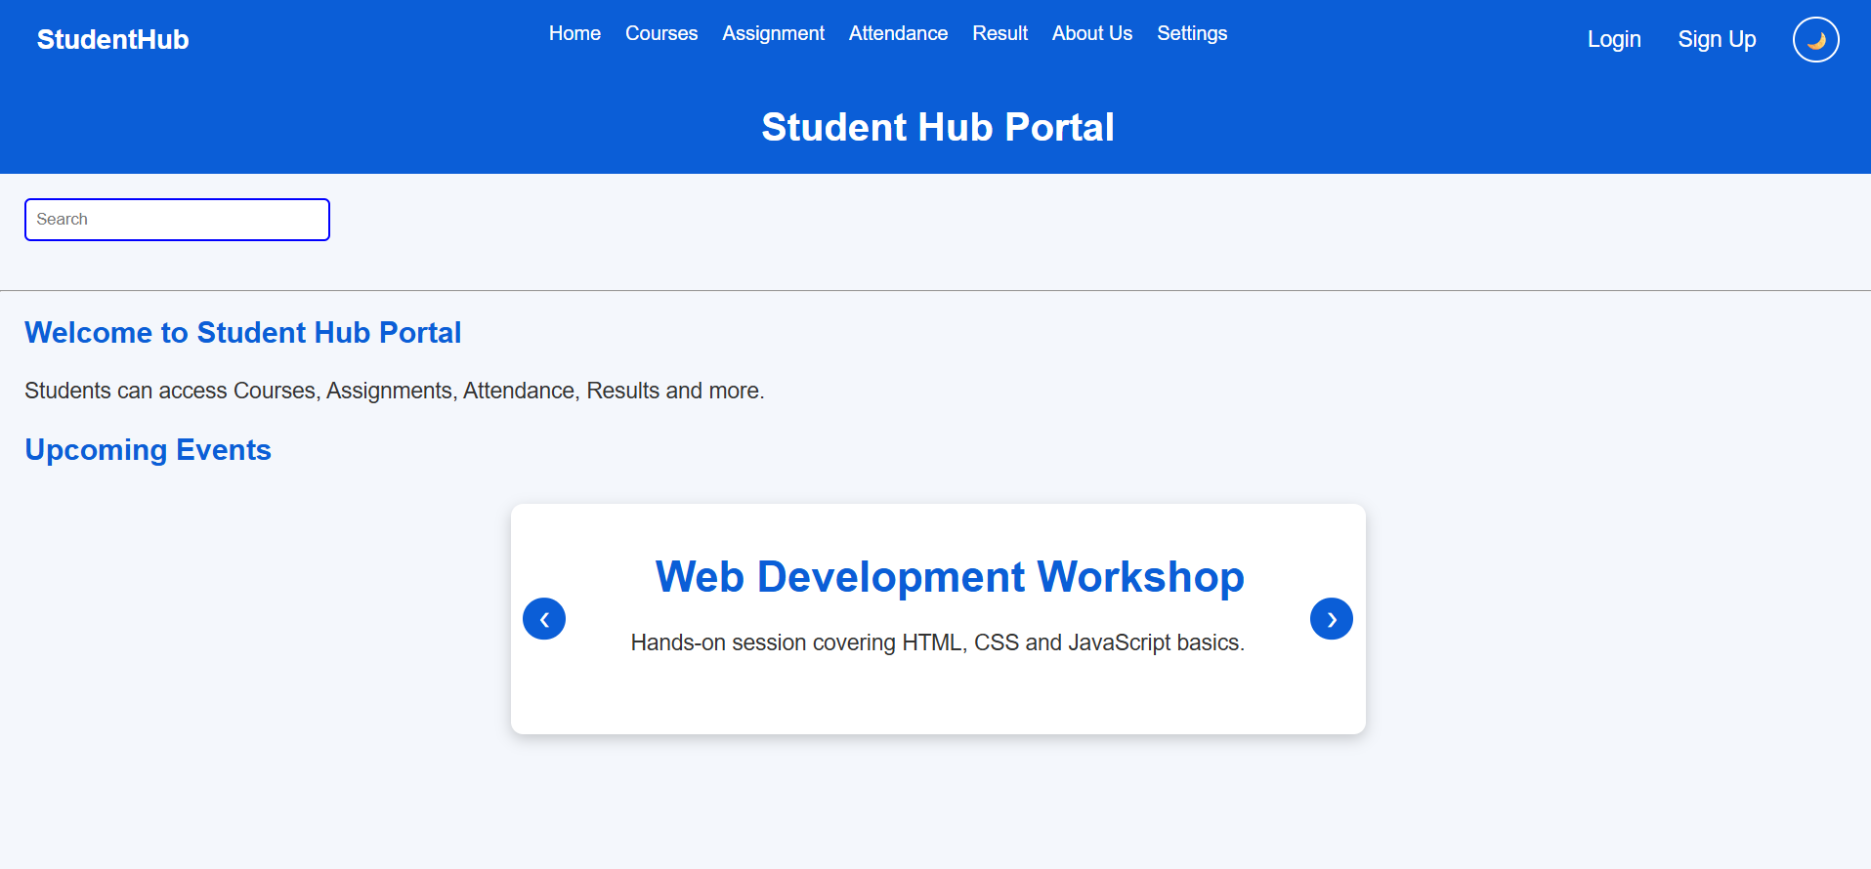
Description: This figure shows the StudentHub Portal home page in light mode. A blue navigation bar at the top contains the StudentHub logo, navigation links, Login and Sign Up options, and a theme toggle. Below it is a search bar, a welcome message, and an Upcoming Events section. The event carousel displays a Web Development Workshop with a short description and left/right navigation buttons.

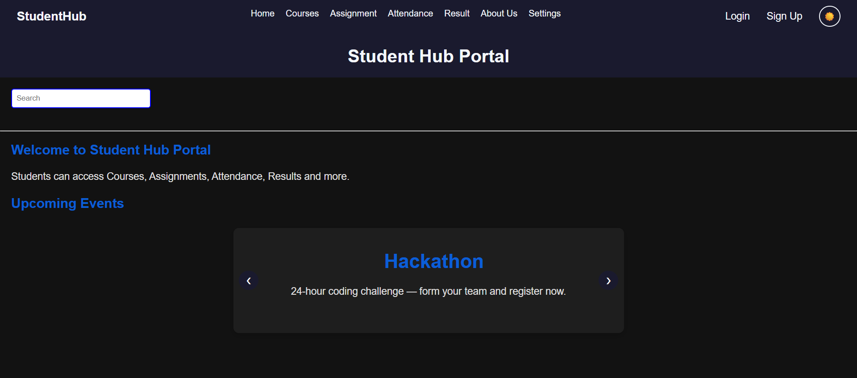
Description: This figure shows the StudentHub Portal home page in dark mode. The interface uses a dark background with a dark navy header while blue is used for headings and highlights. The page contains the same navigation menu, search bar, welcome section, and upcoming events carousel. This time, the featured event is a Hackathon, described as a 24-hour coding challenge.
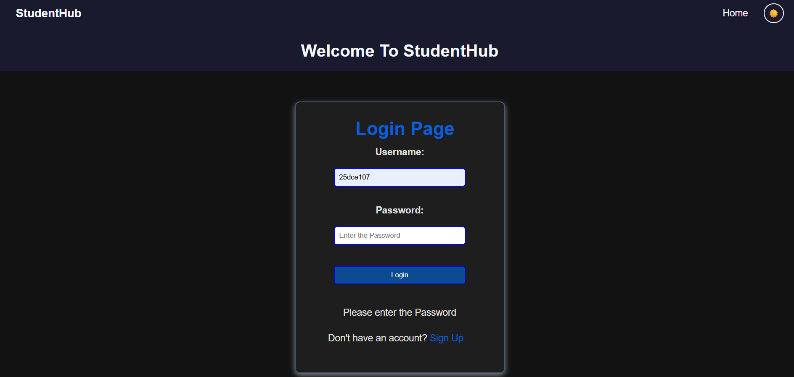
Description: The figure shows the StudentHub Login Page in dark mode. The page has a simple top navigation with the StudentHub logo, a Home link, and a theme toggle. In the center is a login form containing a Username field, Password field, and Login button. A validation message appears below the form, along with a Sign Up link for users who do not have an account.

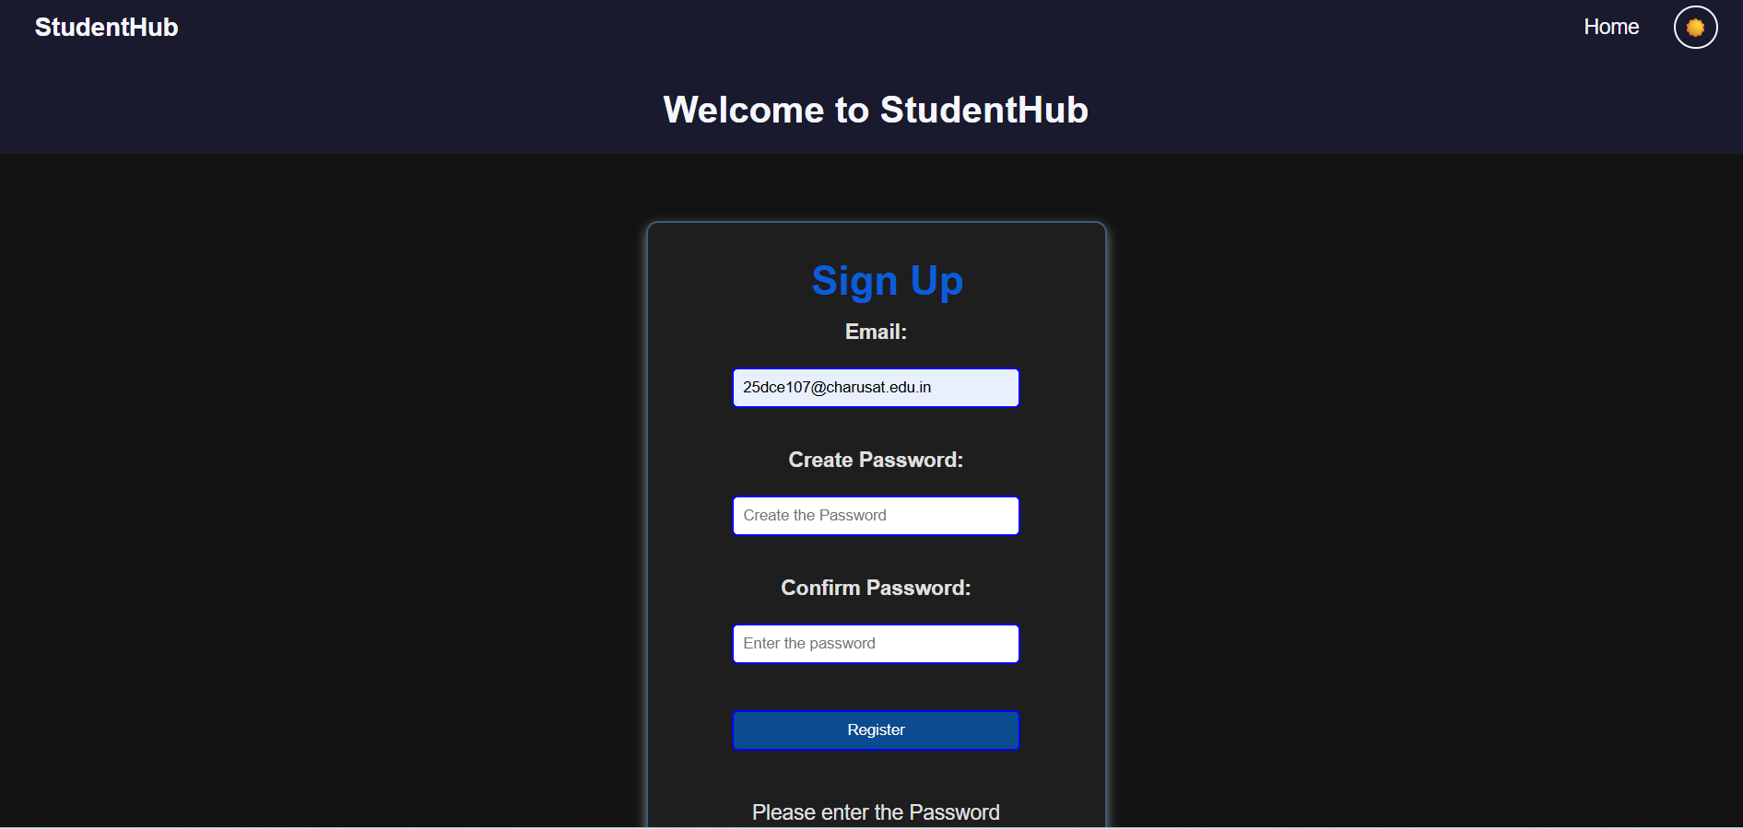
Description: The figure shows the StudentHub Sign Up/Registration Page in dark mode. It has a centered registration form with fields for Email, Create Password, and Confirm Password. A Register button is provided to submit the form, and validation text is displayed below it. The page also includes the StudentHub logo, a Home link, and a theme toggle in the top navigation.
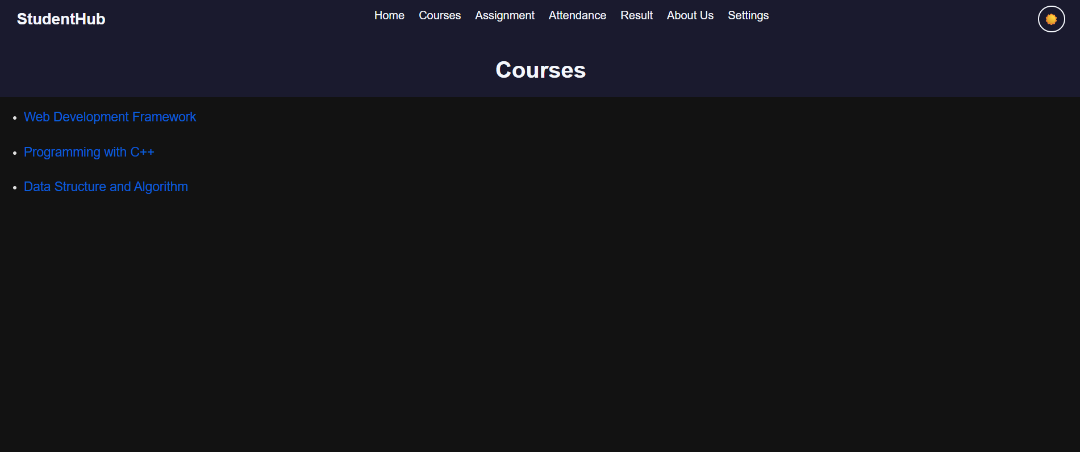
Description: The figure shows the list of courses available to the student. The page uses a dark-themed interface with a navigation bar containing links to Home, Courses, Assignment, Attendance, Result, About Us, and Settings.
Three courses are displayed:
- Web Development Framework
- Programming with C++
- Data Structure and Algorithm
The course names are presented as clickable links, allowing the student to select a particular course and view its details.

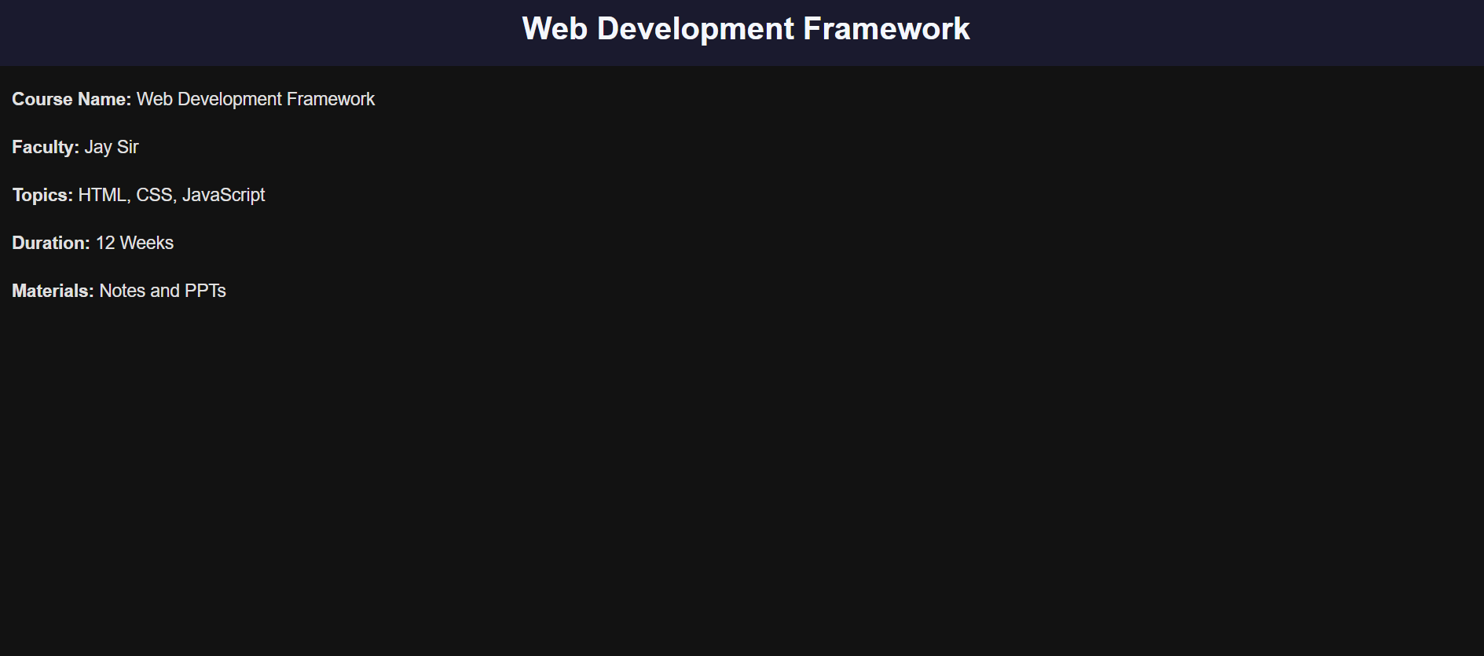
Description: The figure shows the detailed information about the selected course.
It contains:
- Course Name: Web Development Framework
- Faculty: Jay Sir
- Topics: HTML, CSS, JavaScript
- Duration: 12 Weeks
- Materials: Notes and PPTs
The page demonstrates how JavaScript/HTML navigation can be used to move from a course list to a specific course-information page.
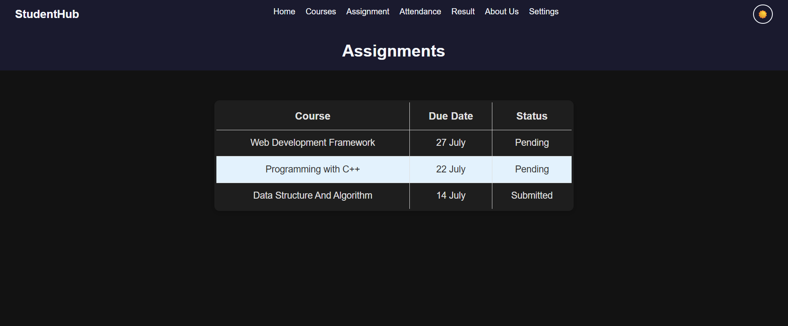
Description: This figure shows the assignment information in a structured table. The table contains three columns:
- Course
- Due Date
- Status
The table makes it easy for students to identify upcoming deadlines and check whether an assignment has been submitted.
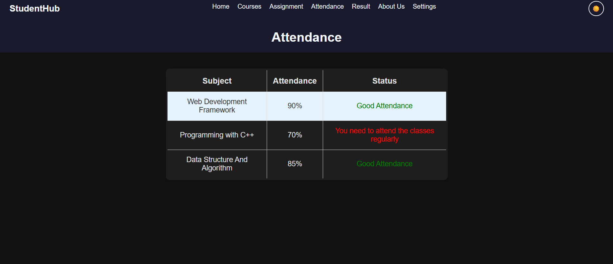
Description: This figure shows the student's attendance for different subjects.
It contains three columns:
- Subject
- Attendance
- Status
The displayed information includes:
- Web Development Framework – 90% – Good Attendance
- Programming with C++ – 70% – You need to attend the classes regularly
- Data Structure and Algorithm – 85% – Good Attendance
The page uses different status messages to provide immediate feedback about the student's attendance.

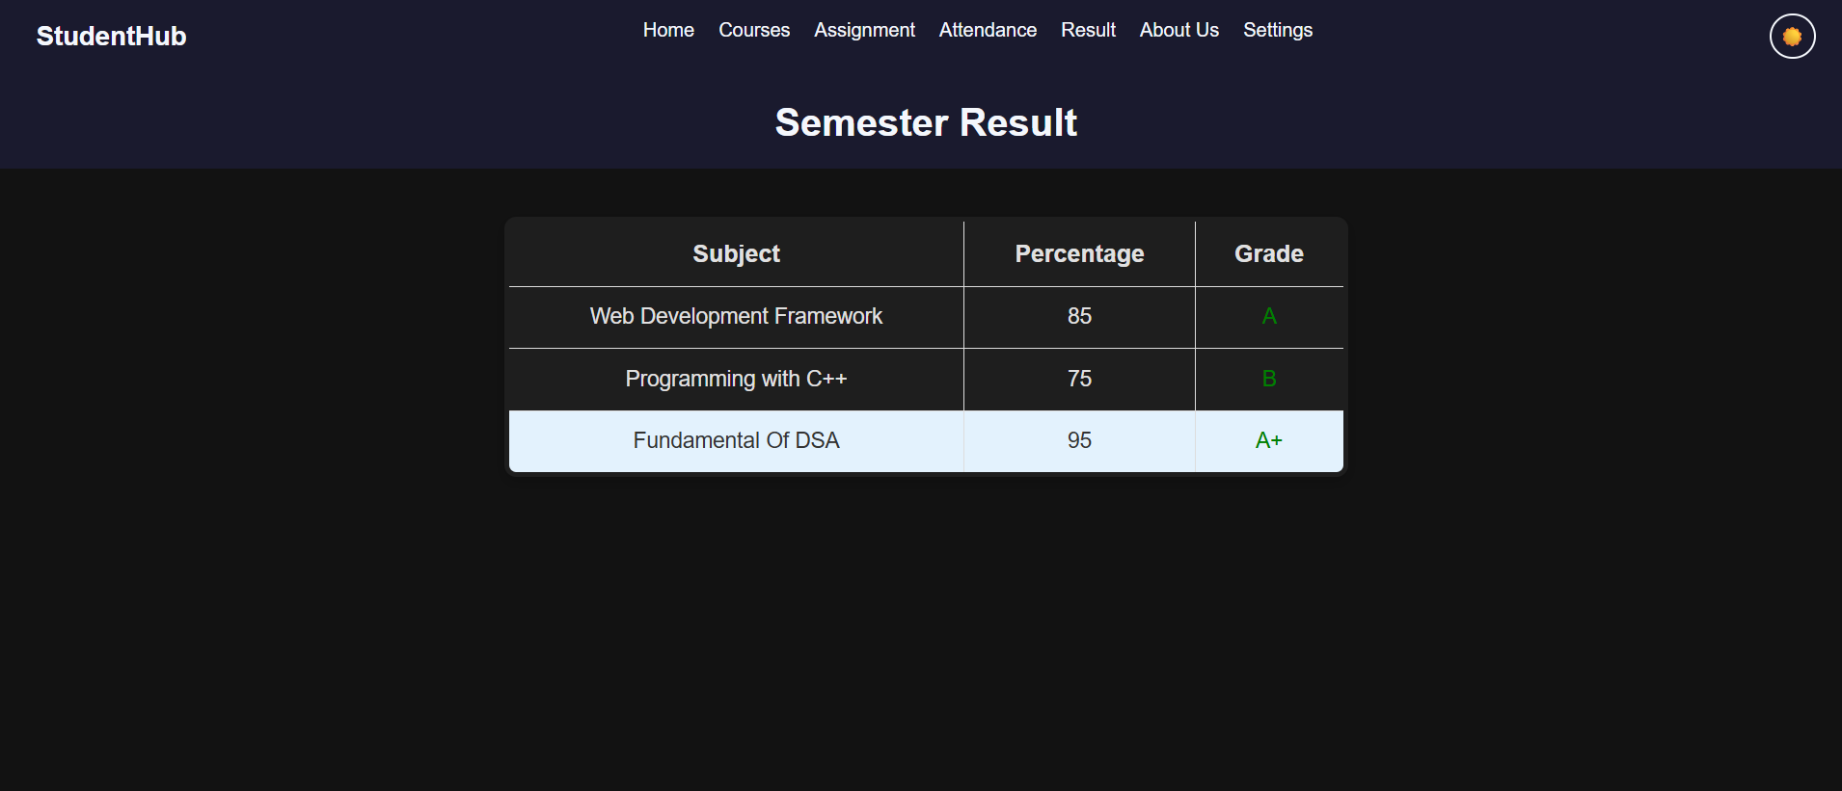
Description: This figure shows the the student's academic performance in a table.
The table includes:
- Subject
- Percentage
- Grade
The results shown are:
- Web Development Framework – 85% – A
- Programming with C++ – 75% – B
- Fundamental of DSA – 95% – A+
The grades are visually highlighted, making it easier for the student to understand their performance.

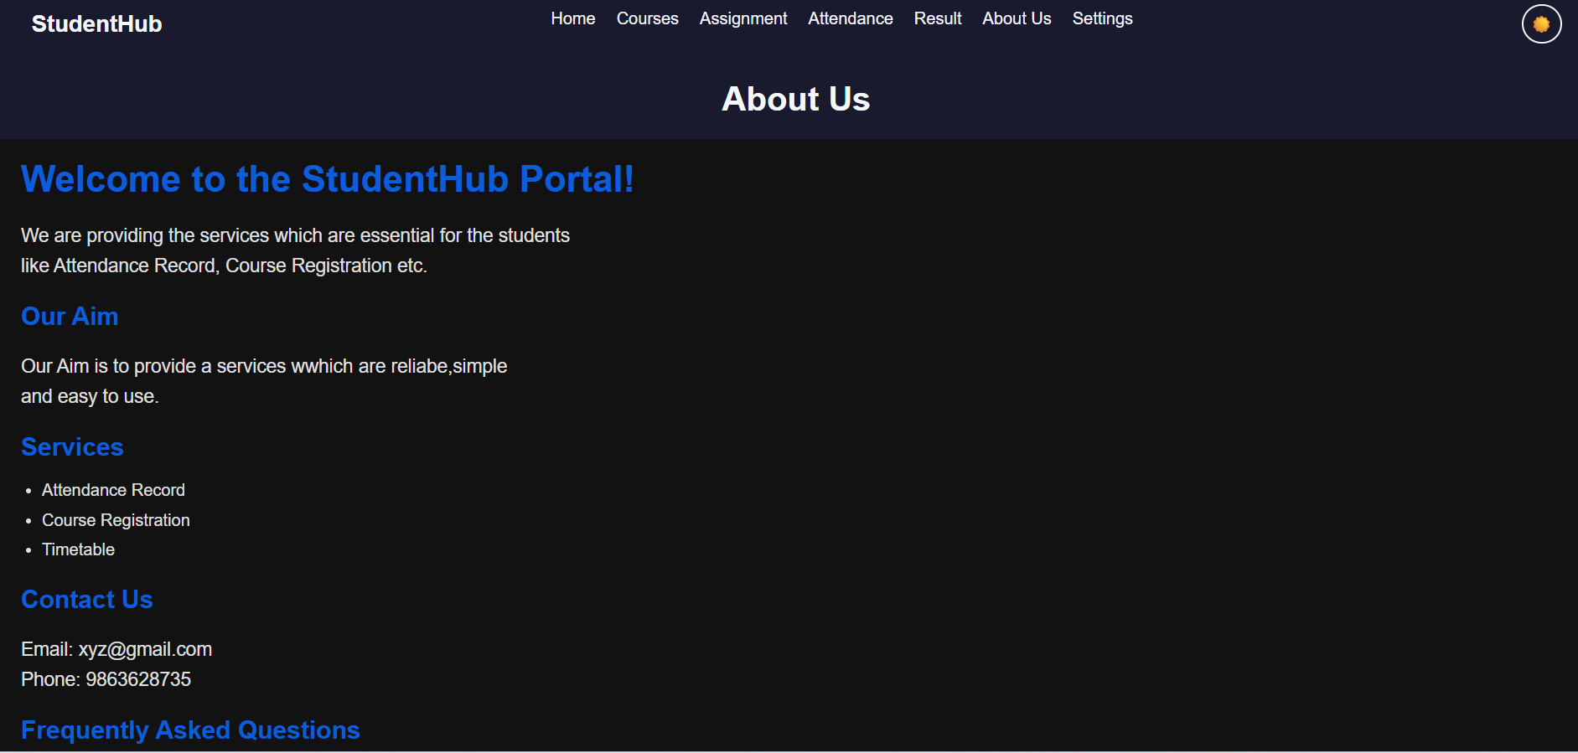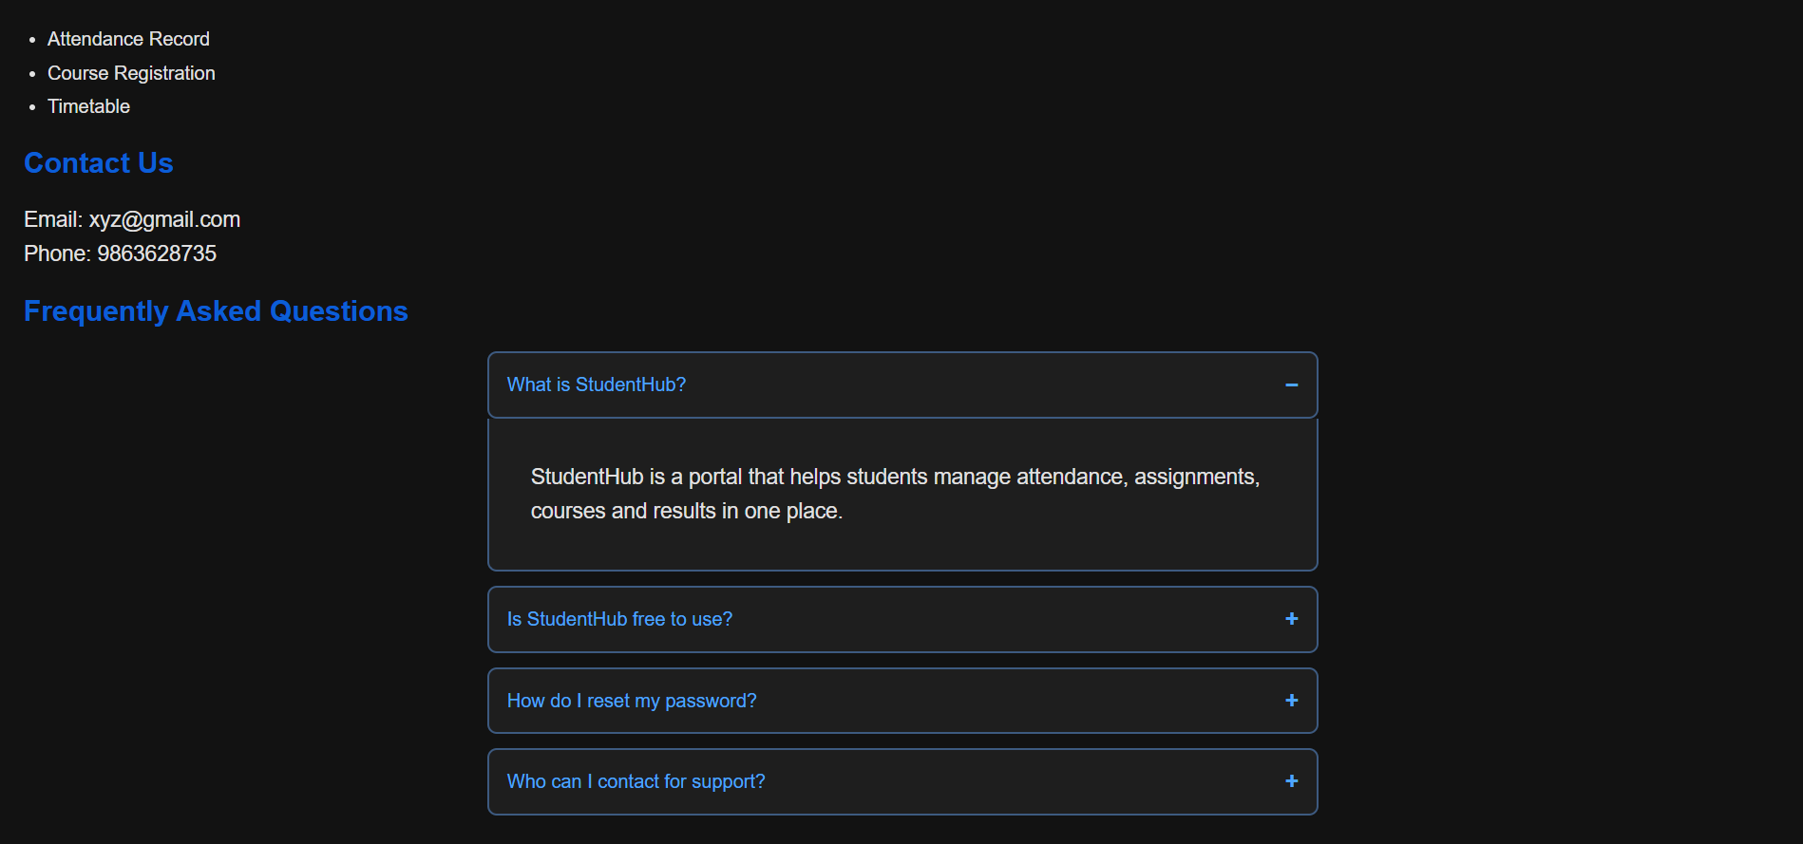
Description: This figure shows the information about the StudentHub portal and its purpose.
It contains sections such as:
Welcome to the StudentHub Portal
The page explains that StudentHub provides services essential for students, including attendance records and course registration.
Our Aim
The aim is to provide services that are reliable, simple, and easy to use.
Services
The portal provides services such as:
- Attendance Record
- Course Registration
- Timetable
Contact Us
The page provides contact information, including an email address and phone number.
Frequently Asked Questions
The page also contains an interactive FAQ section where questions can be expanded or collapsed.
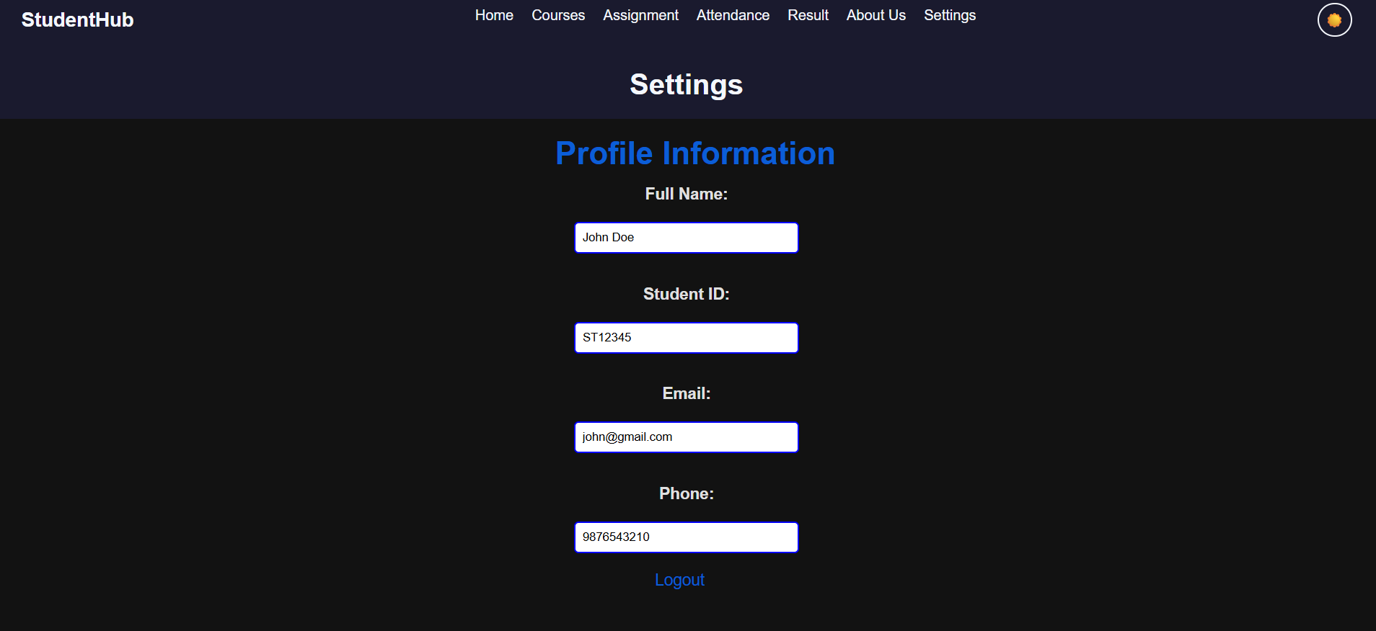
Description: This figure shows the profile information for the student.
It contains fields for:
- Full Name
- Student ID
- Email
- Phone
The page also provides a Logout option.
The profile information is presented in a centered form-like layout, making it easy for users to view or manage their information.

GitHub Repository Link:
https://github.com/devanshirshah24-pixel/WDF-Practicals/tree/main/Practical4

Challenges Faced:

1. Understanding DOM Manipulation
One of the initial challenges was understanding how JavaScript interacts with HTML elements through the DOM. Selecting the correct elements and changing their content, classes, or visibility required careful implementation.

2. Implementing Event Listeners
Attaching click events to buttons, navigation elements, FAQ sections, and the theme switcher was challenging. I had to ensure that the correct JavaScript function was executed whenever the user interacted with an element.

3. Creating the FAQ Accordion
Implementing the expandable and collapsible FAQ section required manipulating the visibility of the answer elements. I also had to make sure that the + and − indicators changed correctly.

4. Implementing Light/Dark Mode
Creating the theme-switching functionality was another challenge. The CSS had to support both themes, while JavaScript needed to add or remove the appropriate class from the page.

5. Maintaining Theme Preference
Using localStorage to remember the user's selected theme required understanding how data can be stored in the browser and retrieved when the page is loaded again.

6. Maintaining Consistent Design
Keeping the same navigation bar, fonts, spacing, buttons, tables, and colors across multiple pages was challenging. Changes to CSS had to be tested across different pages to avoid affecting the layout unexpectedly.

7. Handling Page Navigation
Connecting the different pages, such as Courses, Assignments, Attendance, Results, About Us, and Settings, required ensuring that each navigation link correctly opened the intended page.

8. Responsive and Usable Interface
Making sure that tables, forms, FAQ sections, and other components remain readable and usable on different screen sizes required additional testing and CSS adjustments.

9. Debugging JavaScript Errors
During development, identifying errors in JavaScript event handling and DOM selection was challenging. Browser developer tools and the console were useful for finding and correcting these problems.

Learning Outcomes:
• Understand DOM manipulation and use JavaScript to select and modify HTML elements dynamically.
• Implement event handling using JavaScript event listeners for buttons, links, FAQ sections, and other interactive components.
• Create interactive UI components, such as collapsible FAQs, sliders, theme switches, and dynamic content.
• Use CSS classes with JavaScript to dynamically change the appearance and behavior of web elements.
• Implement light/dark mode functionality to improve the user experience.
• Understand and use localStorage for storing user interface preferences such as the selected theme.
• Develop a multi-page student portal containing courses, assignments, attendance, results, profile settings, and information pages.
• Improve frontend usability by providing clear navigation, visual feedback, and interactive components.
• Debug JavaScript applications using browser developer tools and the browser console.
• Understand the relationship between HTML, CSS, and JavaScript in creating dynamic and interactive web applications.

Faculty Remarks: (Keep this blank for faculty)

